**VILLAGE *of* LAWTON**

**VILLAGE COUNCIL MEETING**

***BEING HELD VIRTUALLY AND REMOTELY***

**Lawton Community Center - 646 N Nursery St, Lawton, MI 49065**

**October 28th, 2020 – 7:00 p.m.**

It has been determined by the Village of Lawton that an electronic meeting is necessary to protect public health. Public participation is encouraged and procedures facilitating that participation are outlined in supplemental materials attached.

***TO ACCESS THE MEETING REMOTELY*:**

**BY PHONE:** Dial +1 (312) 626-6799 and ENTER Meeting ID# 223 344 0545

**BY COMPUTER:** <https://us02web.zoom.us/j/2233440545>& ENTER Meeting ID# 223 344 0545

**AGENDA**

1. **CALL TO ORDER**
2. **ROLL CALL**
3. **PLEDGE OF ALLEGIANCE**
4. **CONSENT AGENDA**
   1. Approval of October 13, 2020 Agenda
   2. Approval of September 9, 2020 Council Meeting Minutes
   3. Approval of Disbursements in the amount of $73,168.02
   4. Establish Policies and Procedures for Remote and Hybrid meetings
5. **COMMUNICATIONS AND CORRESPONDENCE**
6. **CITIZENS’ COMMENTS** – (Please keep comments to 3 minutes)
7. **PUBLIC HEARINGS**
   1. Hear comment on the approval of a ten (10) year Commercial Rehabilitation Exemption Certificate for Walker St LLC located at 99 Walker Street in Lawton, Michigan.

President Opens the Public Hearing

President Receives Public Comment – please limit comments to 3 minutes

President Closes Public Hearing

* 1. Consideration of Resolution 20-10 - A Resolution to Approve a ten (10) year Commercial Rehabilitation Exemption Certificate for Walker St LLC, located at 99 Walker St, Lawton MI…………………...………………………………...……….Staff Recommends Approval

# EXISTING BUSINESS

# Establish Halloween Trick-or-Treating hours within the Village of Lawton for Saturday, October 31, 2020 from 5:30 pm to 7:30 pm…………………..…Staff Recommends Approval

# NEW BUSINESS

# Approve purchase of HP LaserJet Enterprise MFP700 for Village hall in the amount of $2,995, an HP LaserJet Enterprise 500 Color MFP M575 for the Police Department in the amount of $899.00, and HP Monochrome LaserJet Printer for Treasurer in the amount of $289.00 from Precision Printing Services of Portage, MI in a total amount of $4,183…………...…………………………...…………………Staff Recommends Approval

# Approve contract with Wightman Engineering for 2020 Water Reliability Study in the amount of $12,000………………..…………………………….Staff Recommends Approval

# Resolution No. 20-11: A Resolution to Establish Remote Council Member Meeting Participation via Electronic Means……………..…...………….Staff Recommends Approval

# BOARD, COMMITTEE, AND STAFF REPORTS

# Planning Commission

# Downtown Development Authority (DDA)

# Community & Economic Development Committee (CEDC)

# Finance and Administration Committee

# Public Safety Committee

# Public Services Committee

# Water and Sewer Committee

# Police Department

# Department of Public Works

# Village Manager

# COUNCIL COMMENTS

# ADJOURNMENT - NEXT REGULAR MEETING DATE *– November 10th, 2020*

**Please Note:** The Village of Lawton follows the Americans with Disabilities Act of 1990. Individuals with disabilities planning to attend this meeting and require accommodations to observe and/or participate in this meeting, or who have questions regarding the accessibility of this meeting or the facilities, are requested to contact Joni Bell, Village Clerk, at (269) 624-6407, or bellj@lawtonmi.gov to allow the Village to make reasonable accommodations. If you have questions or comments for the Village Council, and you are unable to make the meeting, please forward them to the Village Manager at imusl@lawtonmi.gov.

Posted October 27th, 2020 for the VILLAGE OF LAWTON in VAN BUREN COUNTY, MICHIGAN [www.lawtonmi.gov](http://www.lawtonmi.gov/) *269.624.6407*

# VILLAGE *of* LAWTON

**SPECIAL COUNCIL MEETING**

***BEING HELD VIRTUALLY AND REMOTELY***

**Lawton Community Center - 646 N Nursery St, Lawton, MI 49065**

**October 28th, 2020 – 7:00 p.m.**

## SUPPPLEMENTAL MATERIALS TO AGENDA

**PLEASE NOTICE:** It has been determined by the Village of Lawton that an electronic meeting is necessary to protect the public health. Public participation is encouraged and procedures facilitating that participation are outlined as follows:

**To join the meeting by phone:**

1.) Attend by phone, using your touchtone keypad

* Dial +1 (312) 626-6799
* Enter the Meeting ID# - 223 344 0545

**To join the meeting by Zoom Video Conference:**

1. You will need a computer, tablet, or smartphone with speaker and headphones.
2. In your browse enter this link**:** <https://us02web.zoom.us/j/2233440545>Meeting ID# - 223 344 0545

At the start time of the meeting, enter the link to join via computer. You may be instructed to download the Zoom application. You have an opportunity to test your audio at this point by clicking on “Test Computer Audio.” Once you are satisfied that your audio works, click on “Join audio by computer.”

**We recommend completing these steps ahead of time to assure you are able to connect.**

**REMOTE PUBLIC MEETING PROCEDURE**

Start Recording.

Confirm attendees are muted, and chat, file sharing, screen sharing, video sharing, and similar functions are turned off.

Moderator calls meeting.

Moderator announces Roll Call.

Moderator confirms Board/Council/Commission members’ video and audio is working.

Moderator introduces him/herself.

Moderator announces Agenda.

Moderator announces ground rules for public comment.

1. The Moderator will recognize the public and establish the order of public comment. *Where the conference software does not establish the order of public comment, the Moderator him or herself may do so. For example, the Moderator could state, “We’ll now take public comment. Those wishing to provide comment are requested to announce themselves by stating their first and last name starting with individuals whose last name begins with A. Does anyone have a last name beginning with A who would like to comment?”.*
2. Unless required by law, there shall only be one Public Comment period, which shall be immediately after these instructions. Each Attendee may only comment once for a maximum of 3 minutes.
3. All Attendees are prohibited from the following:
   1. Speaking when not recognized by the Moderator.
   2. Shouting. *iii.* Speaking or texting outside of the public comment period. *iv.* Causing technical disruptions, including but not limited to feedback from microphones, buzzing, etc. whether or not intentional.

*v.* Otherwise disrupting the meeting.

1. The Moderator may mute or bar the disrupting individual from the meeting.

*Prior to excluding the person or muting them for the remainder of the meeting, the Moderator shall provide a warning to the individual that their disruption* ***“constitutes a breach of the peace and it must cease immediately.”*** *It is best to give them multiple opportunities to stop. Further, you should only take action to the extent necessary; if muting the participant solves the problem, then that should be the extent of what is don*e. *Profanity and insults should not be considered a disruption.*

Moderator calls Agenda Item.

Moderator recognizes individual public officials to discuss (for example, “I call on Jane Smith for discussion. … I call on Joe Smith for discussion.”)

Moderator calls for ROLL CALL vote (all votes shall be by roll call).

Moderator calls for the next Agenda Item.

Moderator, in his or her discretion, may deviate from these procedures without a vote of the public body.

Members of the public will only be able to speak during the public comment portion of the meeting and such comment will be limited to three minutes per person. To provide for orderly public participation, a person wishing to speak must state their name and request to be recognized by the Village Council Moderator. The Moderator will recognize all persons wishing to speak during public comment. A copy of the meeting materials and agenda may be found via link on the Village’s homepage at www.lawtonmi.gov.

If you have any questions or comments that you would like addressed to the Village Council, and you are unable to make the meeting, please forward them to the Village Manager at imusl@lawtonmi.gov or 269.624.6407.

The Michigan Relay system will provide auxiliary services for the meeting for those deaf, hard of hearing, or speech impaired. Hamilton Relay is the contracted service provider for Michigan Relay. ***Users may reach Michigan Relay by dialing 7-1-1.***  There is no additional charge to use this service. Only normal telephone charges will be applied. There are no limits to the length or number of calls you place. For more information, visit:

<https://www.michigan.gov/mpsc/0,9535,7-395-93308_93325_93425_94040_94041---,00.html>

The Village of Lawton is subject to the requirements of the Americans with Disabilities Act of 1990. Individuals with disabilities who plan to attend this meeting and who require certain accommodations in order to allow them to observe and/or participate in this meeting, or who have questions regarding the accessibility of this meeting or the facilities, are requested to contact, at a minimum of 3 business days, Joni Bell, Village Clerk, at (269) 624-6407, or jbell@lawtonmi.gov to allow the Village to make reasonable accommodations for those persons.

A copy of this notice is on file with the Village Clerk and may be obtained during normal business hours by calling the number above and requesting an emailed copy.

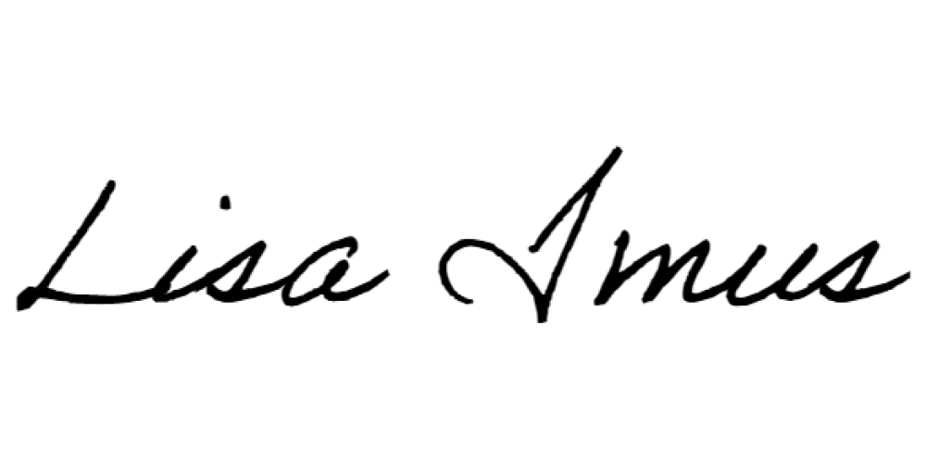Posted on: October 27, 2020 by: _______________________________________

Lisa Imus, Village Manager

VILLAGE OF LAWTON

VAN BUREN COUNTY, MICHIGAN [www.lawtonmi.gov](http://www.lawtonmi.gov/)